**Debra Ballard**

**Otis College of Art and Design**

**Art and Design Colleges: Assessment on Their Own Terms**

Increasing assessment reporting requirements present particular challenges for art and design colleges, particularly in assessing creativity and innovation as learning outcomes. Informal assessment has always been a part of art and design practice; articulating those results and using those results to improve student learning, “closing the loop,” have not been. A review of the assessment literature, particularly in art and design, helped me to create a sustainable and flexible College Assessment Plan (CAP, Appendix A) for the Western Association of Schools and Colleges Assessment Leadership Academy using learning eportfolios, curriculum mapping, and institutional learning outcomes (ILO’s) as assessment tools. By refining and coordinating our existing embedded assessment practices, extending an existing eportfolio initiative, completing an institutional learning outcomes effort, and creating curriculum maps, our improved assessment plan addresses changing accreditation requirements, but more importantly, focuses on improving student learning and success. It will also support our new Strategic Plan in making our rigorous art and design curriculum more visible, so critical in times of increasing college costs and scrutiny and increasingly limited resources.

***Background***

The convergence of broad societal “changing student characteristics and needs; unrelenting technological advances that stretch institutional resources and revolutionize when, where, and how students learn; more intense competition for students; less forgiving economic circumstances that make efficient, effective management of the academic enterprise more challenging; and widespread skepticism about the quality of higher education” (Kuh, et. al, 9-10) along with high costs and low retention/graduation rates have compelled art and design colleges to reflect upon what they do, how they do it, and how they adaptively respond. Dramatic shifts in the world, “wicked problems,” technology, globalization, sustainability, along with shifts in the art and design world demand a discussion on how art and design colleges can contribute to the creative, cultural, and intellectual capital of our society while enduring “the crushing socio-cultural, educational, and political forces. . . .[and] adapt quickly while providing continuity and historical depth” (Buckley and Conomos, 14-27). Part of their adaption and contribution is their response to increasing demands for assessment while preserving if not innovatively expanding their creative mission. A sustainable approach to addressing external forces and making improvement regular and visible can supported through an effective embedded and institutionally meaningful assessment program.

The escalating public demands of accountability and transparency, the Western Association of Schools and Colleges (WASC) redesign around core competencies, and the expanding use of data analytics present obstacles and opportunities for a medium sized single purpose arts institutions. Otis’ formal assessment efforts, focused for our 2008 WASC visit, have mostly been deferred in the subsequent four major changes in senior academic leadership, a not uncommon occurrence since organized meaningful assessment requires consistently strong senior leadership and support.

Art and design colleges share a “continuing evolution of the [higher education] ecosystem [but one] that is peculiar to art school and the education of artists” (Buckley and Conomos, 3) which positions arts’ assessment in a way both distinct and similar to traditional institutions. “When we think about assessing the arts, the words ‘standardized’ and ‘art’ do not sit comfortably together in the same sentence” (Boughton, 267) a concern echoed by WASC’s past president Ralph Wolff’s question for all higher education about the challenge of having “standards without standardization” (Wolfe, WASC ALA Summer, 2012). Assessment is natural to studio practices, yet foreign in the ways that accreditation sometimes frames it. If we can position arts “assessment as a dynamic pedagogy that enhances, extends, supports, and expands student learning” (Driscoll and Wood, 35) that is also inherently natural to art and design and supports several Otis initiatives like Student Success, Retention, and Graduation and the recently approved Strategic Plan, then we can productively embed and sustain good assessment practice within the institution and satisfy growing external demands.

In researching and reviewing assessment at Otis, several themes emerged that frame our college-wide discussion about assessment:

* How do we define institutional mission appropriate levels of achievement in the five core competencies that focus on student success and that are also aligned with our institutional needs and priorities?
* How do we make student learning in these areas more transparent both within and outside the institution and support student agency in their own learning?
* How do we use quantitative and qualitative indicators of performance in improving student learning, retention, and graduation?
* How do we address faculty concerns that accreditation and assessment diminish the innovative and creative components that have become essential 21st century outcomes?
* If the highest functioning art college is constantly questioning, pushing, and changing its parameters, how do we create a dynamic assessment structure that can flexibly move with those changes?
* What are the inherent assessment tensions between arts institutions that inspire resistance by constantly reformulating boundaries and the more static, structured demands of accreditation?
* What does it mean to be creative and assess creativity and innovation in an educational setting?
* How does a medium sized, enrollment driven art and design college create a meaningful and sustainable assessment infrastructure that is embedded in its daily activities and does not detract from but systematically improve teaching and learning?
* How do we include our large part-time faculty in this conversation?
* How do include learning beyond the classroom?

Change seldom is easy, particularly in higher education where long established cultures and traditions have proven successful. “Implementing major, long-lasting change at colleges and universities is a complex and challenging process. It has been observed that changing higher education is like changing a religion in which tradition abounds, the status quo is honored, and any innovation is met with both resistance and high emotion” (Diamond, 15). One potentially useful characteristic of an art and design college is a culture of creativity and divergent thinking that welcomes innovation and is open to reinvention.

Although art and design colleges have particular concerns about assessment’s impact on a creative enterprise, that same creative spirit of innovation can prove quite useful in establishing an assessment framework that encourages creativity, understands failure, and accommodates flexibility. Art and design institutions are exploring what should an art and design education look like in the 21st century in light of challenging changes in the overall landscape of higher education? How do you preserve what has worked so well with the considerable changes that are occurring in society, balancing “thought and action, reflection and agitation, innovation and preservation, intuition and logic”? (Buckley and Conomos, 27).

***Art and Design Assessment***

“There are specific disciplines, especially in the arts, in which developing outcomes appears to be at odds with the philosophy of the discipline” (Driscoll and Wood, 9). Informal assessment has always been a part of art and design practice though until recently it’s something that has evoked little dialogue or scholarship, initiated for the most part by accreditation and public demands for increasing transparency and accountability. Otis has an assortment of assessment activities and like many institutions, most of the formal ones were generated coinciding with accreditation cycles. Although informal assessment has long been a natural part of art and design instruction, formal assessment is generally regarded as accreditation activity that has little to do with the daily activities of an art and design college, and certainly not as part of instructional and programmatic improvement and innovation, enhanced student learning, and student success. Like all institutions in higher education, art and design programs and colleges are also increasingly being challenged to reimagine art education in response to dislocating and disruptive cultural, technological, and global changes. “An evolved profile of contemporary artistic practice has pressed the art school as a pedagogical concept itself to address what an artist is now and what the critical criteria and physical requirements are for educating one.” (Madoff, x). Adapting to those evolving requirements while preserving Otis’ identity rooted in making is an ambitious but necessary conversation where the faculty can frame by assessment efforts because good assessment is at its essence a faculty discussion about what we want students to be able to do, how do determine if they did it, and how do we regularly use those results to improve student learning.

“Assessment in studio is also widely debated by many and has been for some time. There are those who argue that assessment of creative work or design events is difficult, if not impossible, because of the ‘creative’ nature of the final artifacts (Ellmers, 2006); others question whether assessment criteria, particularly quantitative assessment, can truly capture what art products are about” (de la Harpe and Peterson,--- ). A great deal of literature on creativity has been generated, but little has been connected to assessment in art and design; unlike many disciplinary areas, comparatively little has been researched or published in art and design education assessment. This dearth also provides rich opportunities. Acknowledging that assessment need not (and perhaps should not) try to capture all the dimensions of an effective art and design education (or any educational experience for that matter), perhaps the real challenge is learning how to articulate certain outcomes better. A National Schools of Art and Design (NASAD) publication argues that the problem for art and design schools “is not that we do not know how to make assessments and evaluations, but rather that we are not as adept as we need to be in explaining to others what we do, how it works, and why it works” (NASAD, 1). Schon’s call for an epistemology of practice warns of the shortcomings of this. “When a practitioner does not reflect on his own inquiry, he keeps his intuitive understandings tacit and is inattentive to the limits of his scope of reflective attention” (282).

In times of rising costs and shrinking budgets, being able to clearly articulate the invaluable outcomes of an art and design education holds several benefits for perennially underappreciated and often misunderstood art and design programs. “Ironically, despite the shortcomings of certain assessment schemes to quantify art research in the university, such as the Research Assessment Exercise (RAE/UK) and its paler version in Australia, the Research Quality Framework (RQF) . . . these schemes did actually raise awareness of the arts and of art education in the political elites of both countries” (*Rethinking the Contemporary Art School*, 16). As federal and state governments increasingly scrutinize funding and students and parents weigh value, this awareness can become critical to recognizing the value of art and design along with more traditional disciplines.

One of the characteristics of art and design colleges that make the conversation difficult is that the majority of art and design faculty are part-time. An important benefit for students because they are practitioners with current real-world experience, but a pedagogical hurdle because they also have little or no teaching background and little contact with the college outside of their teaching hours. Including them in the conversation is critical because they often create and deliver most of the instruction.

This conversation has pitfalls and provokes anxiety; oftentimes rather than engaging in a genuine (and sometimes contentious) dialogue about the best approaches to assessment, the easier path is adopting existing external frameworks that may not support or even undermine changing art and design teaching paradigms.

Art teachers in the United States do not have the same history of large-scale art assessments as their European counterparts, and are not as well equipped to deal with demands to demonstrate publicly the quality of student achievements through regularized assessments of their subjects. . . .This professional autonomy has long been treasured in the American context so that recent demands for public testing of students in the arts have created new anxieties about public scrutiny for teachers. . . .This is happening at a moment in the evolution of art education when the very opposite kind of assessment is needed to effectively implement important new curriculum ideas. The state of affairs in the United States at present is a showplace of contradictions. On the one hand there is evidence of a significant and much needed revolution in the conception of art education . . . and on the other institutionalized assessment practices are promoting homogeneity across the board assessing inappropriate content, and trivializing subject matter. (Boughton, 216)

The question of whether the essential nature of assessment itself calls for a replication and conformity to the criteria used for assessment can be addressed by the a reconsideration of the criteria itself which if carefully constructed, can lead to greater innovation and originality in a system where the grading plays so much a part of the student’s response. This is not a new concern in art and design assessment where historically the master/apprentice model has been and continues to be used. The nature of arts assessment, “centered in a culture of achievement in an evaluation of whole works rather than a culture of evidence with regard to easily accessible parts” compels art and design professionals to consider what best practices, both quantitative and qualitative, work so they can create “a deeply integrated system of standardization so that results can be compared, and at the same time call for innovation or a climate of innovation” (NASAD, 5-15).

Otis has several existing practices, venues, and developments in place along with a strong history of formal and informal assessment practices that can are used and refined into a more coherent, systematic, and sustainable plan. All departments have developed program goals and learning outcomes. A recent inventory through the Assessment Committee of the departments’ assessment practices includes end-of-the-semester reviews, junior reviews, senior reviews, senior show, juried reviews, in-class critiques, program review, senior capstone, and a variety of embedded assessments, both direct and indirect. Three areas (one of which is well underway) that we can use to expand our assessment efforts with several teaching and learning benefits are our Learning ePortfolios which currently covers all of the Liberal Arts and Sciences classes and many studio classes, curriculum mapping, and the college’s work on the institutional learning outcomes (ILO’s).

***Learning ePortfolios***

I became interested in eportfolios at a WASC Academic Resource conference as a convenient way to archive our “culture of evidence,” but after a good deal of research, particularly in the work of Kathleen Yancey and Donald Schon, became more focused on their pedagogical value, particularly in their use of reflection for long-term retention, metacognition, and creativity. “Good practice in assessment requires multiple assessments over time; well-planned electronic portfolios provide opportunities to collect data from multiple assessments across a broad range of learning outcomes and modes for expressing learning, while guiding students learning and building self-assessment capabilities. (Rhodes, 17). Many of the qualities that define a lifelong learner are found in the very same qualities that characterize a successful art student working “in a landscape of infinitely elastic production” (Madoff, x). These characteristics include “’an adaptable, thinking, autonomous person, who is a self-regulated learner, capable of communicating and co-operating with others’ [with a focus] on the assessment of skills, abilities and capabilities. These qualities are what Claxton refers to as the learner’s ‘toolkit’, which he defines as the three ‘Rs’: resilience, resourcefulness and reflection. If we can develop these qualities in our students then they will be equipped to cope with the super-complexity” of the world they will create in (Bryan and Clegg, 219). Learning eportfolios, a natural extension of the artist’s portfolio, a familiar digital space for digitally comfortable students, provide colleges with a means for evaluating student achievement that can cut across disciplinary lines at an institutional level“ (Cambridge, Cambridge, and Yancey 89).

Recent ePortfolio scholarship has shown that ePortfolios advance student success, make student learning visible, (“by supporting reflection, social pedagogy, and deep learning”), and catalyze “learning centered institutional change” (Kuh et. Al, 37).

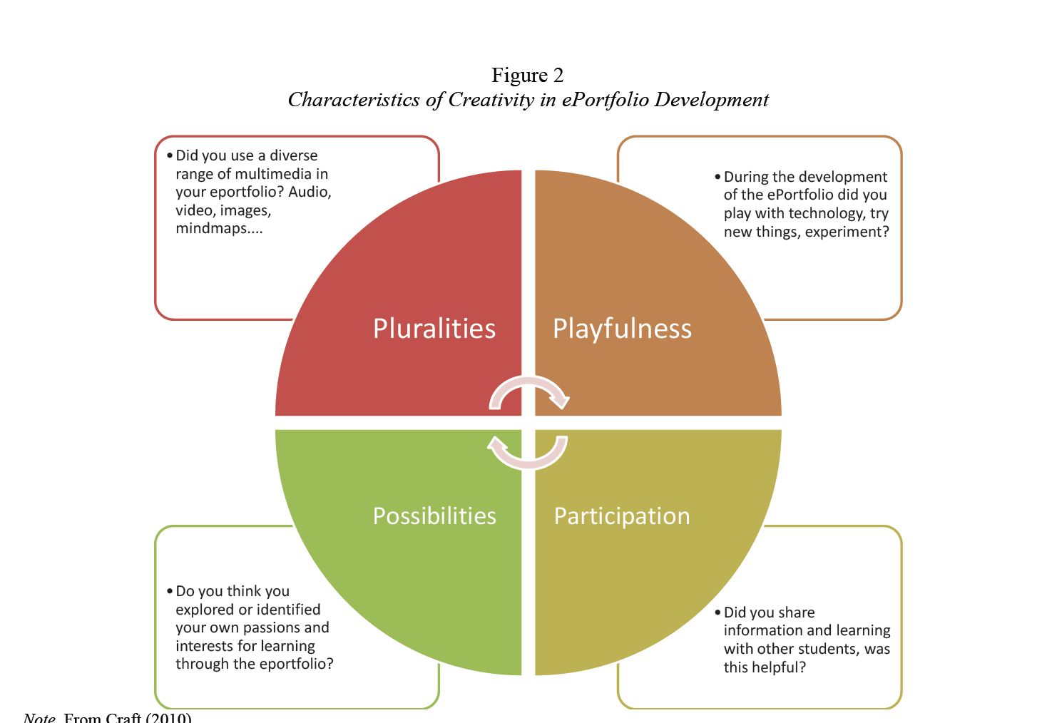

“Explorations of ePortfolios for Adding Value and Deepening Student Learning in Contemporary Higher Education”

Reflection is a critical part of eportfolio learning. Moura Quayle defines reflection in design education as “the reconsideration of an idea or experience. Consciousness, retrospection, introspection, and self-knowledge are facets of the reflective act. . . . Informed reflection, therefore, is a strategy for design learning which creates a bridge from one project to the next” (30). This gives students and faculty an opportunity to look at their work in a more connected way, focusing more on long-term learning, transfer, and retention. Additionally, since during the process of making, attention to the process isn’t and often shouldn’t be explicit, reflection can provide time afterwards to make thinking explicit, building bridges between ideas and strategies over time. In *Educating the Reflective Practitioner “*Schonmakes a case about how reflective practices help a student continue development in professional contexts through becoming more adaptable and effective, learning from the complexities rather than waiting to be trained” (Cambridge, Cambridge, and Yancey, 26). He argues that reflection-in-action is central to the practice of artists and designers in dealing with “situations of uncertainty, instability, uniqueness, and value conflict. . . . The study of reflection-in-action is critically important. The dilemma of rigor or relevance may be dissolved if we can develop an epistemology of practice which places technical problem solving within the broader context of reflective inquiry” (Schon, 37-69). In many ways the time spent at an art and design college can itself be seen as a vehicle for reflection for young artists and designers, a place to “make room for non-instrumental time—time for reflection, for contemplation, for investigations that do not necessarily demand results” (Madoff, 76), a time making connections between complex ideas and challenges, for the productive unknown and cultivated ambiguity, and a time for useful failure, important dimensions of creativity and innovation.

So in the shift from print to electronic, the claims for reflection have widened and increased as well. Three of these claims are that (1) through reflection, students make knowledge by articulating connections among portfolio exhibits, learning and self; (2) reflective activities introduce students to new kinds of self-assessment, often an outcomes–based self-assessment, that they carry into life outside of and beyond educational settings; and (3) through engaging in reflective activities, students develop the stance and practices of a reflective practitioner who can synthesize multiple sources of evidence and make contingent and ethical sense of them. (Cambridge, Cambridge, and Yancey, 5)

Another advantage of learning eportfolios is matrix thinking, a form of design thinking that occurs “when students combine the elements of a matrix and use the resulting conceptual construct as a line through which to revisit work initially created in different contexts for different reasons” (Yancey, 9). Matrix thinking offers art and design students the opportunity to visualize and extend their creative work, and aids in the transference of knowledge and skills by seeing their work from different perspectives. Another type of thinking cultivated by a learning eportfolio is folio thinking, a pedagogical approach in eportfolios which documents process and product in growth over time. The folio thinking project at Stanford sees the problem as students’ fragmented educational experience due to “a lack of curricular coherence. . .increasing demands of an information-rich environment. . . growing importance of out-of-class learning experiences.” Their approach to mitigate these problems is to create learning portfolios where students can reflect on their learning experiences. This enable students to “integrate and synthesize learning. . .enhance their self-understanding. . .make deliberate choices in their learning careers. . .develop an intellectual identity” which draws on experiential learning, metacognition, reflective thinking, critical thinking, and mastery orientation to learning (Chen). To these Otis would add creativity and innovation.

Otis began its Learning ePortfolio effort as a pilot in 2008-2009 with a college-wide launch in 2009 and now covers all classes in all Liberal Arts and Sciences and a number of studio classes. We are using Digication’s eportfolio (and course management system), and are piloting the assessment module. This effort is now annually assessed by the Liberal Arts and Sciences department and Library in coordination with the eLearning Steering Committee.

In support of our student success efforts, there is evidence to show that students who are using an eportfolio have higher completion and retention rates (Kaipolani and LaGuardia in Yancey’s presentation) and coupled with our other student success, retention, and graduation efforts, have valuable potential. “Linking electronic portfolios (Yancey, 2008) and persistence models (Cabrera, Nora, and Casteneda, 1993; Sandler, 2000) is new to higher education research bringing greater insight and refinement to key issues and underlying student beliefs. Assessment using rubrics based on theories and models in the persistence literature provide important quantitative measures such that practitioners and counselors can take steps to stem attrition using electronic portfolios as a source of persistence data” (Sandler, 10-11).

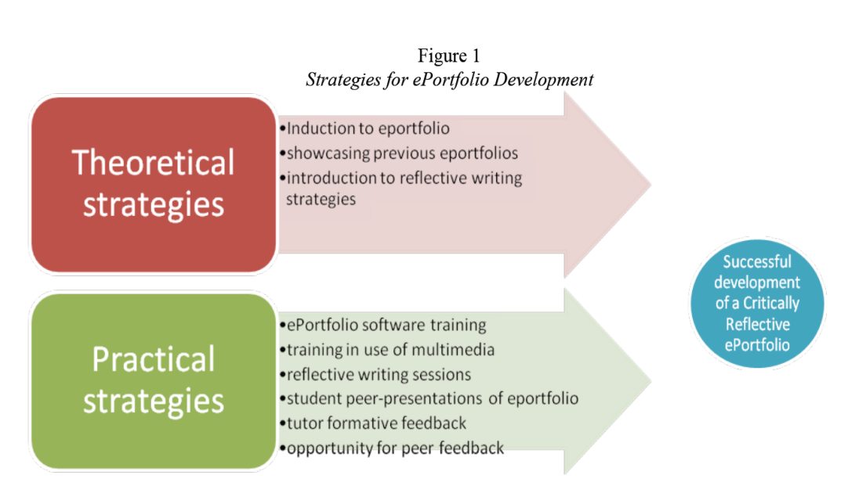

“Explorations of ePortfolios for Adding Value and Deepening Student Learning in Contemporary Higher Education”

Because most of our students receive BFA’s and often go directly from the BFA into a profession, “much of the literature around e-portfolio development stresses their value as a tool which can be used by the learner to present themselves to a future employer or, at the least, can help the learner recognise and consider the evidence for those skills valued by employers” (Strivens, et. al.). Portfolios are a traditional part of art and design practice, and our students have been using them, like professional artists and designers use them. However, this professional dimension of the Learning eportfolios also has to be carefully balanced with the learning aspect and the tension that arises from issues of institutional assessment needs and student ownership demands a thoughtful balanced and structured approach. The Learning e-Portfolio represents a pedagogic departure because portfolio reviews in art schools differ in several respects from professional portfolio reviews. Evidence of improvement and skill development are just two elements that are usually part of judging a student's progress but atypical of considerations employed at the professional level. Also the standards set for a beginner's accomplishment are not as demanding as are those applied in the professional world. However, the critical distinction between the professional portfolio and the learning portfolio offers students practice in critical thinking, audience, and purpose.

There is potential for arts institutions who are always confronted with the challenge of integrating theory and practice. “When someone reflects in action, he becomes a researcher in the practice context. He is not dependent on the categories of established theory and technique, but constructs a new theory of the unique case. . . . He does not separate thinking from doing, ratiocinating his way to a decision which he must later convert to action” (Schon, 68). Another potential benefit from learning eportfolios is integrating Liberal Arts and Sciences, the general education part of the BFA, with studio practice. “Assessment of the student work in e-portfolios can inform programs and institutions on their progress in achieving expected goals for external reporting and, at the same time, provide faculty with information necessary to improve courses and pedagogies” (Rhodes, 17). Studio practice is already visible but practiced in so many different locations and times that capitalizing on that visibility is a challenge that the learning eportfolio accommodates for multiple viewers and evaluators. It also makes learning in Liberal Arts and Sciences more visible to studio faculty (and to other Liberal Arts faculty).Otis is currently collaborating with three other art and design colleges in applying for a Teagle grant to explore this use.

***Curriculum Mapping***

Like my initial interest in the eportfolio, I became interested in Curriculum Mapping and Matrices as a clear visual accreditation assessment method, but as a department chair I quickly saw the value of it as a tool to visually evidence and evaluate the scaffolding of learning outcomes. Program and increasingly institutional curricular alignment, “the extent to which expectations and assessments are in agreement and service in conjunction with one another to guide the system toward students learning what they are expected to know and do” have become key issues of assessment. Curriculum mapping “is a simple but effective tool for improving teaching and learning. . . . Several benefits of curriculum mapping have been identified. Jacobs (1997) suggests that when done in a collaborative format, the curriculum mapping process helps faculty identify gaps, overlaps, inconsistencies, and strengths within a program” (Liu, et. Al., 239). I believe this holds particular promise for institutions like Otis with large contingent faculties who often teach their classes in isolation. Part-time faculty, who deliver most of the instruction at Otis and who often come to us with little or no teaching background, can benefit from seeing how their teaching and course learning outcomes (CLO’s) fit within the department and college’s overall objectives. Like most faculty, they want sufficient direction to situate their teaching within the program while maintaining a degree of autonomy, and since they are part-time, without this effort being too intrusive on their time. Curriculum mapping as an assessment tool supports faculty’s ability to create meaningfully sequenced learning outcomes and assignments because it can be used to both articulate and align curriculum. Using a template with ILO’s and PLO’s, instructors

map their curriculum as it occurs, in real time. . . . The curriculum maps are aggregated first horizontally by course and then vertically across all courses in sequence. Faculty members and department chairs can review maps, identifying strengths, gaps, and overlaps. Once the review is complete, the faculty determines what and where to add or eliminate content and/or strategies, which results in a more streamlined curriculum and integrated program. These maps become living documents for course instructors; and they can be frequently revisited and revised as courses are adapted to the needs of the established curriculum, the [changing] needs of students, or the incorporation of new instructors into the program.” (Uchiyama, Pippin, and Radin, 272-273)

This provides connections and structures while maintaining flexibility. Otis recently implemented credit reduction, and clear curriculum maps can help departments further rebuild their curriculums and outcomes as the credit reduced curriculum moves upward. Rather than thinking about each course individually (which makes changes or reductions insular), an overview of where and at what level PLO’s exist can be an invaluable guide in revising the curriculum.

|  |  |  |  |  |
| --- | --- | --- | --- | --- |
| **Otis College of Art and Design**  **Department Curriculum Map** | | | | |
| **Course** | **PLO/ILO 1** | **PLO/ILO 2** | **PLO/ILO 3** | **Etc.** |
| **Otis 101** | **I** |  | **I** |  |
| **Otis 201** | **P** | **A** |  |  |
| **Otis 301** | **P** | **P** |  |  |
| **Otis 401** | **A** |  | **A** |  |
| **I = Introduces P=Practices A = Advanced** | | | | |

In the past the faculty and staff at Otis have repeatedly expressed interest for some ongoing and meaningful dialogue about teaching and learning. “Assessment becomes an institution’s means to examine its educational intentions on its own terms within the complex ways that humans learn and within the populations the institution serves” (Maki in Driscoll, 34). While addressing the faculty’s genuine desire for dialogue and engagement, it also addresses in a most meaningful way WASC’s Standard 4 that calls for ongoing institutional learning. Uchiyama and Radin (2009) argue that the curriculum mapping process fosters increased collegiality and collaboration among the participating faculty members, in addition to the intended outcomes of a stronger curriculum and better alignment of goals and objectives” (239).

As we move forward in addressing the core competencies in the WASC redesign, curriculum mapping “offers the added value of (1) identifying the different points of assessment for each learning benchmark, (2) showing the logic behind developmentally sequenced course offerings, and (3) allowing for the diagnostic identification of sequential errors or ’holes’ in a curriculum” (Liu, Wrobbel, Blankson). It also allows for faculty members to teach to their strengths by outlining where those strengths are needed, helps in determining if one class is trying to accomplish too much or too little, determines if not enough time is being spent on important LO’s or if too much is spent on a low priority outcome, sets priorities, and aids with transferability of knowledge and skills within and across departments as faculty and chairs use the curriculum map along with the learning eportfolio to briefly review what has been taught in prior classes, and help students make connections they might not make on their own. It can also be used to compare the intended and received curriculum through a comparison of student work and student surveys, and helps makes clearer connections for students as they consider interdisciplinary minors.

***Institutional Learning Outcomes (ILO’s)***

A distinct advantage of Otis’ culture of academic entrepreneurship is that each department is individually developed and strong; one major disadvantage is that the college lacks some curricular unity, coherence about what is characteristic of all Otis graduates. ILO’s are core course and departmental outcomes that describe what departments in an institution agree are the most important abilities, skills, knowledge, values, and attitudes that all students should acquire as a result of successfully completing its degree. ILO’s connect Liberal Arts courses with studio courses, the Integrated Learning program with other programs, and studio courses in one program with studio courses in other programs. A recommendation from our 2008 WASC visit, in a provost lead initiative Otis completed ILO’s framed around the core art and design values, WASC core competencies, and AAC&U’s Essential Learning Outcomes (Appendix B). They provide a common framework for learning within and across disciplinary boundaries; a common point of departure for professional fields and the Liberal Arts; transparent connections between majors; and guidance for students navigating multiple fields of study and institutions (*College Learning for the New Global Century*). As students increasingly move between majors, these common outcomes become even more critical connectors. The Institutional Learning Outcomes created through two provost lead efforts are ones determined by the faculty and departments--collaboration, social responsibility, skills and techniques, visual fluency, and creativity along with the WASC core competencies--critical thinking, written and oral communication, information literacy, and quantitative literacy (Appendix C).

***Creativity and Innovation as a Learning Outcomes***

Creativity/innovation learning outcomes are expected outcomes for an art and design college, but like critical thinking, determining what constitutes creativity and how to measure them varies across the disciplines. “Subsequent investigation showed widespread disagreement among the various design and creative arts disciplines (within the University and beyond) on what constitutes creativity and what constitutes creative ability; whether creative ability could or should be reduced to quantifiable parameters for assessment; and whether the most important aspects of creative achievement reside in the initial thinking (creative ideas) or in the subsequent process of development of the idea (‘crafting’ a work of art, design, etc.) or in the creative work that is the end product (the work of art itself)” (Cowdry and Williams, 1). Despite these differences, in developing creative outcomes, “scientific studies of the creative process find that there are substantial similarities in the creative process across all disciplines” (Sawyer and Lingo, 26). This increasing focus on creativity as a 21st century learning outcomes is becoming more evident in many countries and educational systems as graduates must manage environmental, social, and economic complexity in ways not expected of earlier graduates.

Creativity has also emerged as an element of the ‘generic skills’ and ‘graduate attributes’ movement. Employers of university graduates in Australia have indicated that they value the ‘skill’ of creativity more highly than any other. . . . The significance of including creativity amongst the most important areas of learning was highlighted by the World Conference on Higher Education (UNESCO 1998), where creativity was proclaimed as an ‘innovative educational approach’. Creativity, then, must be regarded as an essential component of any learning situation and a discussion of what creativity means must take place within every discipline and classroom interaction.” (Reid and Petocz, 50- 51)

The challenges that creativity as a learning outcome presents include little understanding of how creativity is educationally accomplished, disagreements about what it means (person, process, or product), and the quite legitimate concerns about assessment being counterproductive to cultivating creativity, or creativity being an intangible and un-assessable dimension that we just know when we see it. However, oftentimes “when people use terms such as ‘art’ and ‘intuition,’ they usually intend to terminate discussion rather that to open it up to inquiry” (Schon, viii). In order to look at creativity, pedagogy and assessment, seeing creativity “not as an effable concept but [as] something real and tangible that can be analyzed and understood, and that understanding can be utilized to develop students’ creativity and their creative processes and products” (Kleiman, 2). Based on regular instructional activities in art and design, we know that student outcomes in products and ideas are often graded for creativity and this often serves as “the proof or evidence that creativity has occurred. It **is** because it is a product and therefore tangible that makes it the easiest element to assess. . . .What is required is an assessment process that both values and recognizes creativity, and meets the requirements of the quality. . . . any valid assessment system that seeks to encourage and evaluate creativity, needs to reflect both the requirement of validity and reliability and the contingent nature of creativity in its own formation and implementation” (Kleiman, 8-18).

In addition to the five core competencies that WASC has outlined in its redesign, Otis has added creativity and innovation as one of its mission specific ILO’s. As we continue to enroll students who are less prepared in art and design, and often distracted by the seduction of being “always on” through digital technology, some thoughtful developmental approach to how creativity is cultivated in the curriculum is called for. In “Assessing Creativity: Strategies and Tools to Support Teaching and Learning in Architecture and Design,” the authors argue that the three key challenges facing design education are little understanding of creativity’s pedagogical concerns; lack of understanding of strategies to understand where different levels of creativity occur and how to asses them; and the lack of good models to support assessment of creative works (Williams and Ostwald, 4). The work of Paul Kleiman in a negotiated assessment system organized under six assignment weighted assessment fields, presentation / production, process, idea, technical, documentation, and interview (16) holds interesting promise as does work that looks at constructive internal reflection to “promote effective balance between external attention and internal reflection” which is critical for “potentially important for making meaning of new information and for distilling creative, emotionally relevant connections between complex ideas” (“Rest is Not Idleness,” 352-359). Alongside Bloom’s Taxonomy, John Bigg’s work on SOLO Taxonomy (Structured Overview of Learning Outcomes) that addresses increasing complexity through the five stages: pre-structural, uni-structural, multi-structural, relational, and extended abstract has the potential to look at the quantitative and qualitative aspects of art and design assessment.

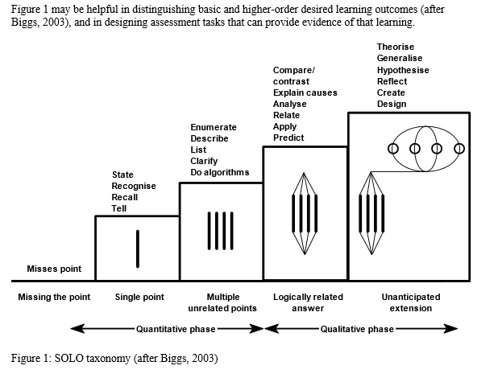

Our assessment plan will hopefully evoke and frame the equally critical discussion about what does it mean to do assessment in the arts. “Assessment promotes sustained instructional dialogue about teaching and learning. . . . Building a collective commitment to assessing student learning also involves establishing new and different relationships for dialogue” (Maki in Driscoll, 16). A dialogue about what we do in art and design education is something the departments have repeatedly asked for in the past and this provides an appropriate occasion and avenue for that dialogue.

*Conclusion*

The continued demands for accountability, external demands for student and institutional performance are not going away and if anything, will increase. “Modern society requires a fundamentally different conceptual discourse for assessment. . . . ‘What is urgently needed now is the beginnings of an active search for a more humanistic, even intuitive, approach to educational assessment which is more in keeping with the spirit and needs of the times’” (Clegg and Bryan, 224). Art and design programs must take the lead in this discussion, not in a defensive or compliant way, but in innovatively bold ways but something that can increases our students’ agency in their curating and analyzing their education.

Our future challenges and opportunities are considerable. In *Using Evidence of Student Learning to Improve Education* the authors analyzed five existing trends to predict what most likely is coming next. First there is a shift from the institution and departments to the individual students who are learning in many different ways and who need to understand their levels of performance and be able to demonstrate personal progress and performance. Next, technology enhanced platforms will provide greater instructional and student work flexibility as well as reporting possibilities. Third, the role and expectations of providers will continue to expand and faculty development will take on more importance as we rethink teaching and learning models and how we assess them. Fourth the continuing emergence of credentialing frameworks (MOOCs, badges, etc.) will require different assessment frameworks than what exists now. Lastly “a major driver of change in American higher education in the years ahead will be a harsher, less forgiving economic environment that will place a greater premium on evidence of what students know and are able to do” (225-229).

A discussion around the particular open-ended nature of art and design assessment should produce a discourse that expands the concept of assessment in other innovative areas. How these assessment practices in art and design can be sustainable, looking at the practices, knowledge, skills, predispositions necessary to support lifelong learning that “meet the needs of the present” but also support students’ capacity to meet their own learning needs in the future (Williams and Ostwald, 23), and also flexibly meet faculty and accreditation needs of the present without compromising their ability to effectively teach art and design practices that meet evolving future needs, is the question that our assessment plan works to address. The most important reason for art and design education to respond to these increasing demands is that the lack of response leaves art and design fields vulnerable to the more quantitative aspects of assessment, standardized testing, or standards imposed from the outside without a valid understanding of what types of assessment support art and design outcomes, particularly in light of changes that are occurring that respond to 21st learning outcomes where “designing a desirable future and inventing ways to bring it about” (Schon, 16), by proactively leading assessment and change rather than reactively trying to manage it, can be one of the contributions that a socially responsible art and design education can make.

Bibliography

Al-Amri, Mohammed. "Assessment Techniques Practiced in Teaching Art at Sultan Qaboos University in Oman." *International Journal of Education Through Art* (2011): 267-282. Ebsco Host OmniFile Full-Text. Web. 11 Sept. 2012.

Banta, Trudy. “A Morning with Trudy Banta” WASC ALA, July, 2012.

Biggs, J. B., & Collis, K. F. (1982). Evaluating the quality of learning: the SOLO taxonomy (structure of the observed learning outcome). New York: Academic Press.

Boughton, Doug. "From Fine Art to Visual Culture: Assessment and the Changing Role of Art Education." *International Journal of Education Through Art* 1(2002): 211-223. Ebsco Host OmniFile Full-Text. Web.

Bresciani, Marilee. “A Morning with Marilee Bresciani” WASC ALA, July 31, 2012.

Bryan, Cordelia and Karen Clegg. *Innovative Assessment in Higher Education*. Psychology Press, 2006.

Buckley, Brad and John Conomos, eds. *Rethinking the Contemporary Art School*. Nova Scotia: The Press Of The Nova Scotia College Of Art And Design, 2009. Print.

Cambridge, Darren, Barbara Cambridge, and Kathleen Yancey, eds. *Electronic Portfolios 2.0: Emergent Research on Implementation and Impact.* Virginia: Stylus Publishing, 2009. Print.

Castiglione, Lawrence V. "Portfolio Assessment in Art and Education." *Art Education Policy* 97(1996): 2-9. Ebsco Host OmniFile Full-Text. Web.

Chen, Helen. “Supporting Individual Folio Learning: Folio Thinking in Practice.” NLII Annual Meeting, January 27, 2004.

Cowdry, Rob, and Anthony Williams. "Assessing Creativity in the Creative Arts." *Art, Design, and Communication in Higher Education* 5.2 (2007): 97-117. Ebsco Host OmniFile Full-Text. Web.

De la Harpe, Barbara and Fiona Peterson. “A model for holistic studio assessment in the creative disciplines.”

http://www.ojs.unisa.edu.au/index.php/atna/article/viewFile/339/238

Diamond, Robert M, ed. *Field Guide to Academic Leadership.* San Francisco: Jossey-Bass, 2002. Print.

Driscoll, Amy M., and Swarup Wood. Developing Outcomes-based Assessment for Learner-Centered Education. Virginia: Stylus Publishing, 2007. Print.

Harland, Robert, and Phil Sawdon. "From Fail to First: Revising Assessment Criteria in Art and Design." *Art, Design and Communication in Higher Education* 10.1 (2011): 67-88. Ebsco Host OmniFile Full-Text. Web.

Glass, N. R. (2008). *College Learning for the New Global Century: A Report from the National Leadership Council for Liberal Education and America's Promise Shared Futures: Global Learning and Liberal Education.*

Gruber, Donald G., and Jack A. Hobbs. "Historical Analysis of Assessment in Art Education." Art Education 55.6 (2002): 12-17. Ebsco Host OmniFile Full-Text. Web.

Kuh, George D., Stanley O. Ikenberry, Natasha A. Jankowski, Timothy Reese Cain, Peter T. Ewell, Pat Hutchings, and Jillian Kinzie. *Using Evidence of Student Learning to Improve Higher Education*. San Francisco: Jossey Bass, 2015.

Immordino-Yang, Mary Helen, Joanna A. Christodolou, Vanessa Singh. “Rest Is Not Idleness: Implications of the Brain’s Default Mode for Human Development and Education.” *Perspectives on Psychological* Sciences. 2012 7: 352.

Joe, Jilliam N., Christine J. Harmes, Carol L. Barry. “Art and Humanities General Education Assessment: A Qualitative Approach to Developing Program Objectives.” *The Journal of General Education.* October 2008, Vol 57 Issue 3, p 131-151.

Kleiman, Paul. “Beyond the Tingle Factor: creativity and assessment in higher education.”

Kleiman, Paul. “Negotiating Assessment: an approach to assessing practical work, including assessment criteria.” Palantine working paper, 2007.

http://www3.wooster.edu/teagle/docs/Beyond%20the%20Tingle%20Factor.pdf

Liu, Min, Duff Wrobbel, and Isaac Blankson. "Rethinking Program Assessment Through the Use of Program Alignment Mapping Technique." *Communication Teacher* 24.4 (2002): 238-246. Ebsco Host OmniFile Full-Text. Web.

Madoff, Steven H, ed. *Art Schools: Proposition for the 21st Century. Cambridge*, MA: MIT Press, 2009. Print.

NASAD Policy Brief, “Assessment on Our Own Terms.” January 2009.

Nichols, Karen W. and James O. Nichols. *The Department Head’s Guide to Assessment Implementation in Administrative and Educational Support Units.* New York: Agathon Press, 2000.

O’Keefe, Muireann and Roisin Donnelly. “Explorations of ePortfolios for Adding Value and Deepening Student Learning in Contemporary Higher Education.” *International Journal of ePortfolio. Vol. 3, No 1, pps. 1-11, 2013.*

Quayle, Moura and Douglas Paterson. *The Journal of Architectural Education*, Vol 42, No 2, Winter, 1989 pp. 30-42.

Reid, Anna, Peter Petocz. “Learning Domains and the Process of Creativity.” *Australian Educational Researcher*, Vol 31, Number 2, August 2004.

<http://www.ethiopia-ed.net/images/720692088.pdf>

Terrell L. Rhodes, “Valid Assessment of Learning in Undergraduate Education.” *Rising to the Challenge: Meaningful Assessment of Student Learning*. Association of American Colleges and Universities, American Association of State Colleges and Universities, Association for Publich and Land-grant Universities. FIPSE project, October 2007-Janurary 2010.

Rohrbach, Stacy. “Analyzing the Appearance and Wording of Assessments: Understanding their Impact on Students’ Perception and Understanding, and Instructors’ Processes.”

http://www.designresearchsociety.org/docs-procs/DRS2010/PDF/102.pdf

Rohrbach, Stacie. “Educational Assessment in Emerging Areas of Design: Toward the Development of Systematic Framework Based on a Study of Rubrics.”

http://shura.shu.ac.uk/488/

Rust, C. “The impact on studio learning: how can the research literature practically help to inform the development of departmental assessment strategies and learner-centered assessment practices?” *Active Learning in Higher Education*, 3, 145-157, 2002.

Sandler, Martin E. “First Year Student Adjustment, Success, and Retention: Structural Models of Student Persistence Using Electronic Portfolios.” ERIC, ED509752 Online Submission, Paper presented at the Annual Meeting of the American Educational Research Association (Denver, CO, Apr 30-May 4, 2010), published 2010-04-30.

Sawyer, Keith and Elizabeth Long Lingo. “Creativity in the Arts: Its Role in the University.” Arts Engine Task Force Interim Report, March 2012.

Schon, Donald A. *Educating the Reflective Practitioner*. USA: Basic Books, 1983. Print.

Singerman, Howard. *Art Subjects: Making Artists in the American University*. University of California Press, Berkeley and Los Angeles, 1999. Print.

Strivens, Janet, David Baume, Simon Grant, Catherine Owen, Rob Ward, and David Nicol. “The Role of e-Portfolios in Formative and Summative -Assessment.” Report of the JISC–funded Study, Centre for Recording Achievement, August 2009.

Uchiyama, Kay Pippin, and Jean L Radin. “Curriculum Mapping in Higher Education: A Vehicle for Collaboration” *Innovative Higher Education* 5.1 (2009): 21-27. Ebsco Host OmniFile Full-Text. Web.

WASC 2013 Handbook of Accreditation Revised.

http://www.wascsenior.org/resources/handbook-accreditation-2013

Williams, Anthony and Michael J. Ostwald. “Assessing creativity: Strategies and tools to support teaching and learning in architecture and design.” Final Report, 2012, The University of Newcastle (Lead).

Wolff, Ralph. “An Afternoon with Ralph Wolff and Susan Clifford. ALA, Oakland, August 1 2012.

Yancey, Kathleen. *Reflection in the Writing Classroom*. Utah State University Press, Utah: 1998.

Yancey, Kathleen. “A Morning With Kathleen Yancey” ALA, Oakland, August 1 2012.

**Appendix**